Vehicle Movement Based Street Lights with External Light Sensing

The main aim of this project is that it saves energy by putting on the lights of the system only when the system detects movement of vehicle. The system switches on the street light ahead of the vehicle and switches off the trailing lights simultaneously. In order to detect movement of vehicles, sensors are used. The system automatically puts on the lights that are ahead of the vehicle detected and as soon as the vehicle moves ahead, the trailing lights are switched off. This is better than the existing system where the street lights are kept on always unlike this system where the street lights are put on only when movement of vehicle is detected which helps in saving lot of energy.
During day time these lights are dim as this system has the capability to sense external lights. Thus this system senses the external light and then accordingly puts ON or OFF the street lights. It uses PWM to control the intensity through microcontroller. The sensors sense the vehicle movements and send it to a microcontroller that initiates commands for switching the lights ON/OFF.

Block Diagram
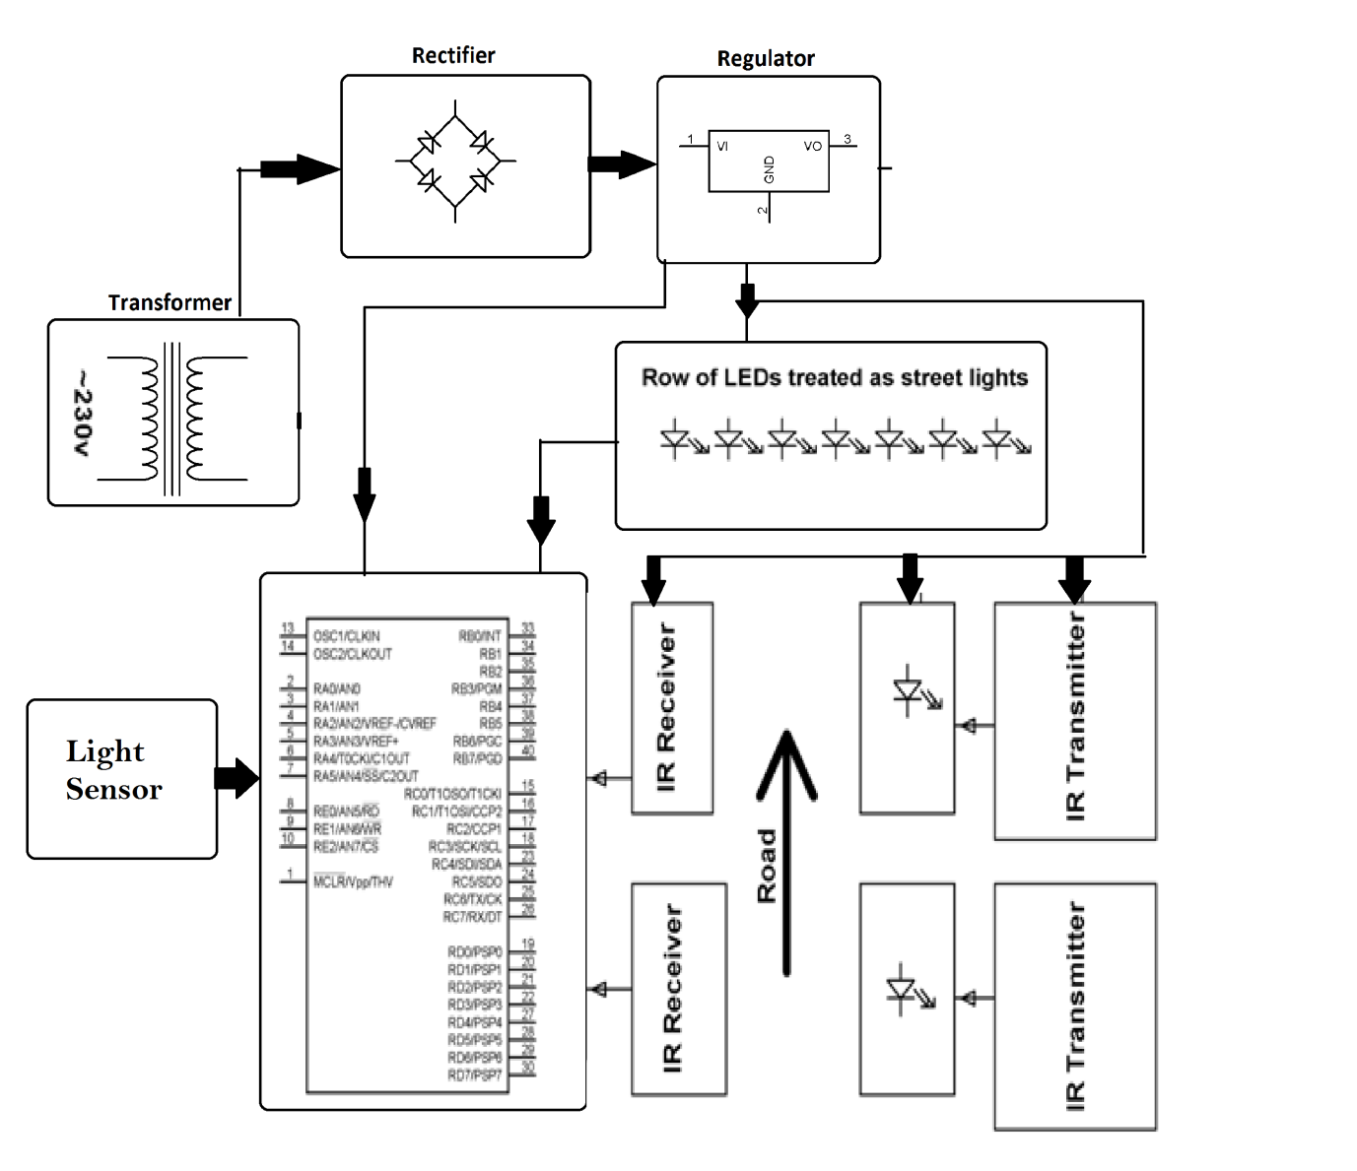

Hardware Specifications
- 8051 series microcontroller
- LEDs
- Transformer
- IR LEDs
- Diodes
- Light Sensor
- Transistors
- Voltage Regulator
- Photodiodes

Software Specifications
- Keil µVision IDE
- MC Programming Language: Embedded C

Reference
- http://ieeexplore.ieee.org/xpl/articleDetails.jsp?arnumber=5524348&queryText=vehicle%20sensing%20light&newsearch=true

